DSA0602 – DATA HANDLING AND VISUALIZATION
CLASS ACTIVITY 2: RELATIONSHIP WORKSHOP IN R – SLOT D
R.No: 4 Reg. No: 192324305 Name: AYESHA SIDDIQA S

1 – Scatterplots

Aim
To study the relationship between weekly sales (Rs lakh) and footfall (visitors per day), identify the outlier, and compare linear and quadratic regression fits.

R Code
# Q1: Scatterplots
library(ggplot2)
set.seed(1284053)
n <- 24
sales <- round(rnorm(n, 85.0, 18.0), 1)
z <- (sales - 85.0) / 18.0
footfall <- round(900 + 200.0 * (-0.61 * z + -0.76 * z^2 + 0.39 * rnorm(n)), 0)
footfall[8] <- round(footfall[8] + 3.2 * 200.0, 0)
df <- data.frame(sales, footfall)
# Scatterplot with linear and LOESS fits
p <- ggplot(df, aes(x = sales, y = footfall)) +
geom_point(color = "#0072B2", size = 2.8) +
geom_smooth(method = "lm", se = FALSE, color = "#D55E00", linewidth = 0.9) +
geom_smooth(method = "loess", se = FALSE, color = "#009E73",
linewidth = 0.9, linetype = "dashed") +
labs(title = "Weekly Sales vs Footfall",
x = "Weekly sales (Rs lakh)",
y = "Footfall (visitors per day)") +
theme_minimal()
print(p)
# Correlation and straight-line slope
cat("Correlation r =", round(cor(df$sales, df$footfall), 4), "\n")
linear_model <- lm(footfall ~ sales, data = df)
cat("Linear slope =", round(coef(linear_model)[2], 4), "\n")
# Outlier using largest absolute standardised residual
std_res <- rstandard(linear_model)
outlier_row <- which.max(abs(std_res))
cat("Outlier row =", outlier_row, "\n")
cat("Outlier sales =", df$sales[outlier_row],
"; footfall =", df$footfall[outlier_row],
"; standardised residual =", round(std_res[outlier_row], 4), "\n")
# Compare linear and quadratic models
quadratic_model <- lm(footfall ~ sales + I(sales^2), data = df)
cat("Linear model R-squared =", round(summary(linear_model)$r.squared, 4), "\n")
cat("Quadratic model R-squared =", round(summary(quadratic_model)$r.squared, 4), "\n")
cat("Better fit by R-squared =",
ifelse(summary(quadratic_model)$r.squared > summary(linear_model)$r.squared,
"Quadratic model", "Linear model"), "\n")

Output
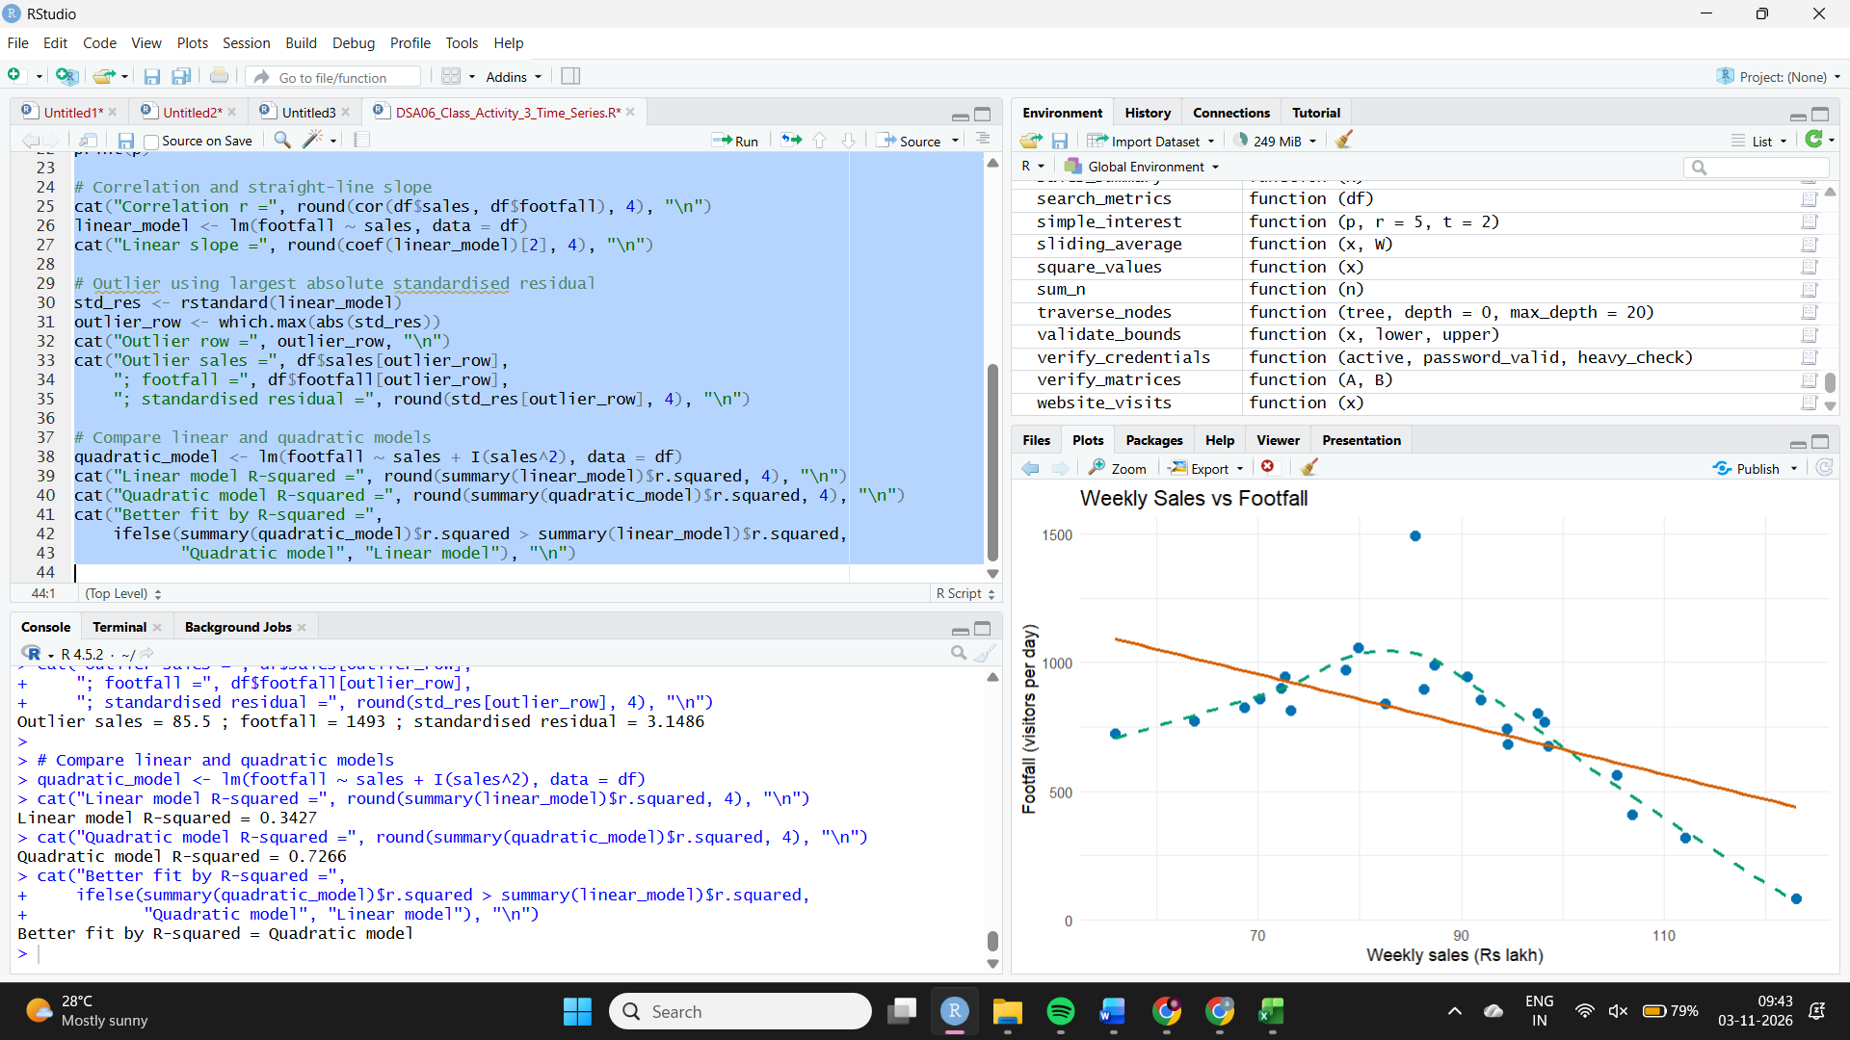

Q2 – Correlograms

Aim
To calculate and visualise the correlations among six telecom measures and identify the strongest and weakest relationships.

R Code
# Q2: Correlogram
library(ggplot2)
set.seed(1284106)
n <- 30
f1 <- rnorm(n)
f2 <- rnorm(n)
tower_density <- round(14.0 + 4.0 * (0.76 * f2 + 0.65 * rnorm(n)), 1)
drop_rate <- round(2.6 + 0.7 * (0.75 * f1 + 0.66 * rnorm(n)), 1)
traffic_tb <- round(320 + 70.0 * (0.85 * f2 + 0.53 * rnorm(n)), 0)
users_lakh <- round(24.0 + 6.0 * (0.77 * f1 + 0.64 * rnorm(n)), 1)
churn_pct <- round(1.8 + 0.5 * (-0.85 * f1 + 0.52 * rnorm(n)), 1)
arpu <- round(rnorm(n, 185, 25.0), 0)
df <- data.frame(tower_density, drop_rate, traffic_tb,
users_lakh, churn_pct, arpu)
# Correlation matrix
cor_mat <- cor(df)
print(round(cor_mat, 2))
# Convert matrix to long format for ggplot2
cor_long <- as.data.frame(as.table(cor_mat))
names(cor_long) <- c("Variable1", "Variable2", "Correlation")
p <- ggplot(cor_long, aes(x = Variable1, y = Variable2, fill = Correlation)) +
geom_tile(color = "white") +
geom_text(aes(label = sprintf("%.2f", Correlation)), size = 3) +
scale_fill_gradient2(low = "#0072B2", mid = "white", high = "#D55E00",
midpoint = 0, limits = c(-1, 1)) +
labs(title = "Correlation Matrix of Telecom Measures",
x = "Measure", y = "Measure", fill = "Correlation") +
theme_minimal() +
theme(axis.text.x = element_text(angle = 45, hjust = 1))
print(p)
# Find the two strongest unique pairs by absolute correlation
upper <- cor_mat
upper[lower.tri(upper, diag = TRUE)] <- NA
pair_table <- as.data.frame(as.table(upper))
pair_table <- pair_table[!is.na(pair_table$Freq), ]
pair_table$Abs_r <- abs(pair_table$Freq)
pair_table <- pair_table[order(-pair_table$Abs_r), ]
cat("Two strongest pairs:\n")
print(head(pair_table, 2))
# Weakest non-diagonal pair
cat("Weakest pair by absolute correlation:\n")
print(tail(pair_table[order(pair_table$Abs_r), ], 1))

Output
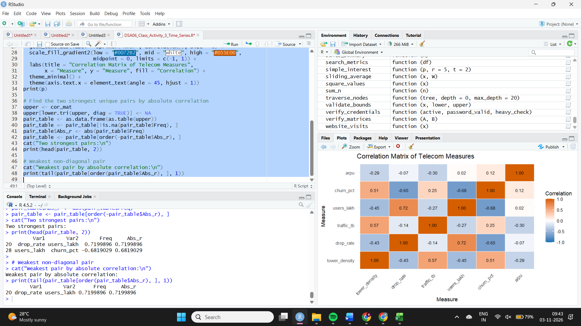

Q3 – Dimension Reduction (PCA and t-SNE)

Aim
To reduce six destination measures into principal components, assess group separation, and compare PCA with t-SNE.

R Code
# Q3: PCA and t-SNE
library(ggplot2)
set.seed(1284182)
n <- 36
grp <- rep(c("Group B", "Group C", "Group A"), each = 12)
g <- rep(c(-1, 0, 1), each = 12)
footfall_k <- round(120.0 + 30.0 * (rnorm(n) + 0.70 * g), 1)
spend_rs <- round(3200 + 600.0 * (rnorm(n) + 0.30 * g), 0)
stay_nights <- round(2.8 + 0.7 * (rnorm(n) + 0.60 * g), 1)
rating10 <- round(7.6 + 0.8 * (rnorm(n) + 0.03 * g), 1)
occupancy_pct <- round(68.0 + 10.0 * (rnorm(n) + 1.10 * g), 1)
complaints <- round(4.0 + 1.2 * (rnorm(n) + 0.07 * g), 1)
df <- data.frame(footfall_k, spend_rs, stay_nights,
rating10, occupancy_pct, complaints)
# PCA on scaled data
pca <- prcomp(df, scale. = TRUE)
variance_pct <- (pca$sdev^2 / sum(pca$sdev^2)) * 100
cat("PC1 variance percentage =", round(variance_pct[1], 4), "\n")
cat("PC2 variance percentage =", round(variance_pct[2], 4), "\n")
cat("Components needed for at least 80% =",
which(cumsum(variance_pct) >= 80)[1], "\n")
scores <- as.data.frame(pca$x)
scores$grp <- grp
p <- ggplot(scores, aes(x = PC1, y = PC2, colour = grp)) +
geom_point(size = 3) +
scale_colour_brewer(palette = "Dark2") +
labs(title = "PCA: Destinations on PC1 and PC2",
x = "Principal Component 1",
y = "Principal Component 2", colour = "Group") +
theme_minimal()
print(p)
# Largest absolute loading on PC1
pc1_loading <- pca$rotation[, 1]
cat("Largest absolute PC1 loading variable =",
names(which.max(abs(pc1_loading))), "\n")
cat("Its PC1 loading =", round(pc1_loading[which.max(abs(pc1_loading))], 4), "\n")
# R-squared for group explanation of PC1 and PC2
r2_pc1 <- summary(lm(PC1 ~ grp, data = scores))$r.squared
r2_pc2 <- summary(lm(PC2 ~ grp, data = scores))$r.squared
cat("R-squared for PC1 explained by group =", round(r2_pc1, 4), "\n")
cat("R-squared for PC2 explained by group =", round(r2_pc2, 4), "\n")
# t-SNE plot
if (!requireNamespace("Rtsne", quietly = TRUE)) {
install.packages("Rtsne")
}
library(Rtsne)
set.seed(1284182)
tsne_fit <- Rtsne(scale(df), dims = 2, perplexity = 5,
check_duplicates = FALSE, pca = TRUE)
tsne_df <- data.frame(TSNE1 = tsne_fit$Y[, 1],
TSNE2 = tsne_fit$Y[, 2],
grp = grp)
p2 <- ggplot(tsne_df, aes(TSNE1, TSNE2, colour = grp)) +
geom_point(size = 3) +
scale_colour_brewer(palette = "Dark2") +
labs(title = "t-SNE Map of Destinations",
x = "t-SNE Dimension 1", y = "t-SNE Dimension 2",
colour = "Group") +
theme_minimal()
print(p2)

Output
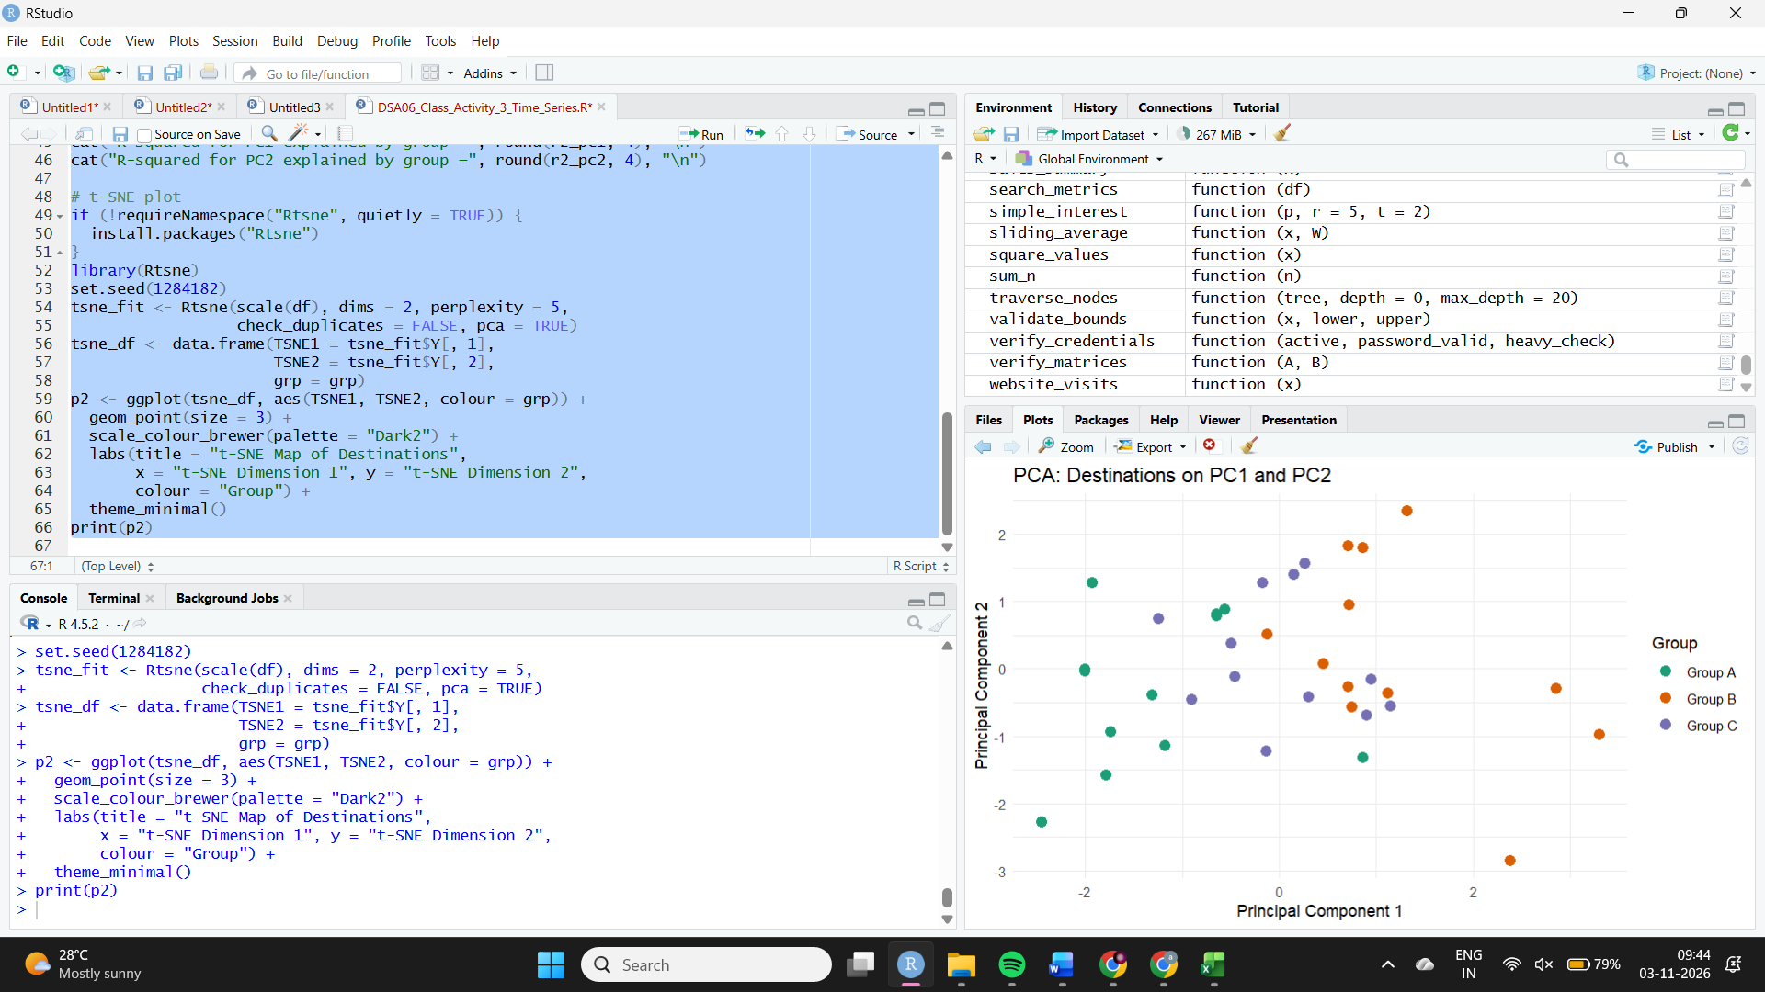

Q4 – Network Graphs

Aim
To construct a parcel-flow network of eight hubs, calculate node centrality and network structure, and examine the effect of removing the most central hub.

R Code
# Q4: Network Graph
library(igraph)
set.seed(1284212)
nodes <- c("Mumbai", "Chennai", "Ahmedabad", "Kolkata",
"Hyderabad", "Pune", "Delhi", "Bengaluru")
pairs <- t(combn(nodes, 2))
u <- runif(nrow(pairs))
keep <- u < 0.26 | ((pairs[, 1] == "Ahmedabad" |
pairs[, 2] == "Ahmedabad") & u < 0.93)
edges <- data.frame(from = pairs[keep, 1],
to = pairs[keep, 2],
weight = round(runif(sum(keep), 1, 20)))
# Build graph and draw it
g <- graph_from_data_frame(edges, directed = FALSE,
vertices = data.frame(name = nodes))
deg <- degree(g)
btw <- betweenness(g, directed = FALSE, normalized = FALSE)
plot(g,
layout = layout_with_fr(g),
vertex.size = 12 + 5 * deg,
vertex.label = V(g)$name,
vertex.label.cex = 0.8,
vertex.color = "#56B4E9",
edge.width = 1 + E(g)$weight / 5,
edge.color = "grey55",
main = "Parcel Flow Network Between Hubs")
# Centrality values for every node
centrality <- data.frame(Node = names(deg),
Degree = as.numeric(deg),
Betweenness = as.numeric(btw))
print(centrality)
central_node <- names(which.max(btw))
cat("Most central node (highest betweenness) =", central_node, "\n")
cat("Its degree =", deg[central_node], "\n")
cat("Its betweenness =", round(btw[central_node], 4), "\n")
# Network summary
cat("Number of edges =", ecount(g), "\n")
cat("Network density =", round(edge_density(g), 4), "\n")
cat("Connected components =", components(g)$no, "\n")
# Remove the most central node
g_removed <- delete_vertices(g, central_node)
cat("Components after deleting", central_node, "=",
components(g_removed)$no, "\n")

Output
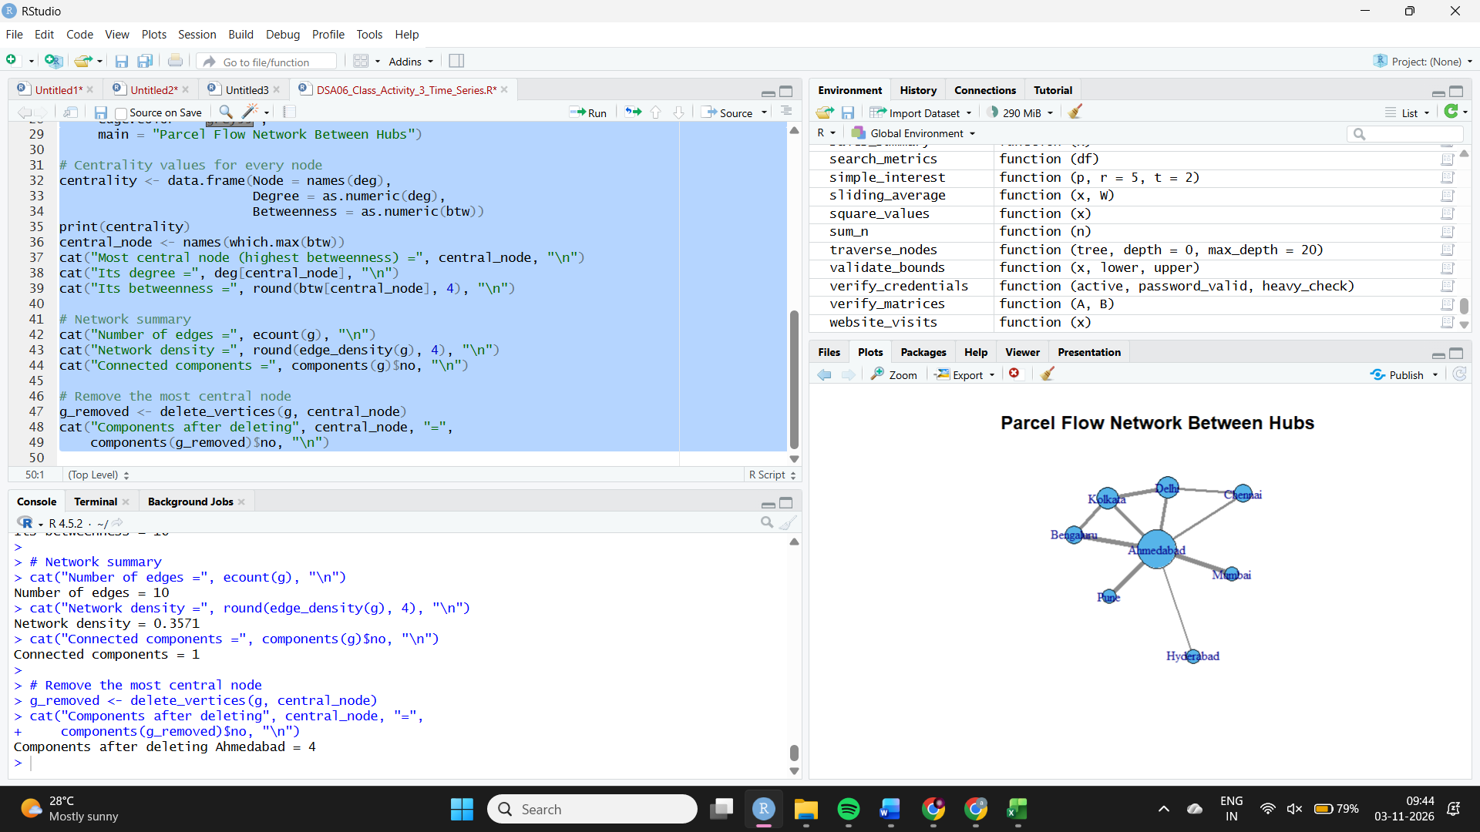

Q5 – Paired Data

Aim
To compare patient waiting times before and after a process change across six departments, classify the changes, and perform a paired t-test.

R Code
# Q5: Paired Data / Slope Chart
library(ggplot2)
set.seed(1284265)
entity <- c("Orthopaedics", "Pharmacy", "Cardiology",
"Radiology", "Neurology", "Paediatrics")
n <- 6
before <- round(rnorm(n, 42.0, 5.0), 1)
change <- round(c(-1, 1, 1, -1, -1, 1) * runif(n, 0.4, 1.4) * 6.0, 1)
change[5] <- 0.1
after <- before + change
df <- data.frame(entity, before, after)
df$change <- df$after - df$before
# Convert to long format for paired slope chart
long_df <- rbind(
data.frame(entity = df$entity, period = "Before", wait = df$before),
data.frame(entity = df$entity, period = "After", wait = df$after)
)
long_df$period <- factor(long_df$period, levels = c("Before", "After"))
p <- ggplot(long_df, aes(x = period, y = wait, group = entity,
colour = entity)) +
geom_line(linewidth = 0.8) +
geom_point(size = 2.5) +
geom_text(data = subset(long_df, period == "After"),
aes(label = entity), hjust = -0.08, size = 3,
show.legend = FALSE) +
scale_colour_brewer(palette = "Dark2") +
labs(title = "Patient Waiting Time Before and After Process Change",
x = "Process period", y = "Waiting time (minutes)",
colour = "Department") +
theme_minimal() +
coord_cartesian(clip = "off")
print(p)
# Classify: flat if absolute change is below 0.420 minutes
df$status <- ifelse(abs(df$change) < 0.420, "Flat",
ifelse(df$change < 0, "Improved", "Worsened"))
print(df[, c("entity", "before", "after", "change", "status")])
cat("Improved =", sum(df$status == "Improved"), "\n")
cat("Worsened =", sum(df$status == "Worsened"), "\n")
cat("Flat =", sum(df$status == "Flat"), "\n")
# Largest absolute change
i <- which.max(abs(df$change))
cat("Largest change department =", df$entity[i], "\n")
cat("Change in minutes =", round(df$change[i], 4), "\n")
cat("Change percentage =", round(100 * df$change[i] / df$before[i], 4), "%\n")
# Paired t-test
test <- t.test(after, before, paired = TRUE)
cat("Paired t-test t =", round(unname(test$statistic), 4), "\n")
cat("Paired t-test p-value =", format.pval(test$p.value, digits = 4), "\n")
cat("Mean change (after - before) =", round(mean(df$change), 4), "minutes\n")

Output
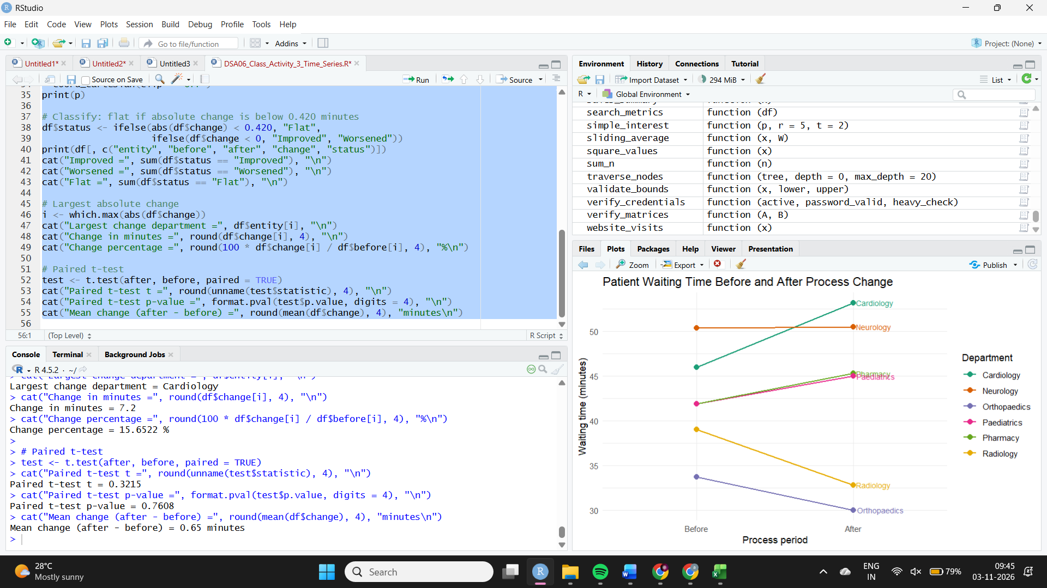

Q6 – Bubble Charts

Aim
To compare seven content genres using marketing spend, watch time and subscriber count, and identify a genre with an unusually large subscriber count.

R Code
# Q6: Bubble Chart
library(ggplot2)
set.seed(1284318)
entity <- c("Drama", "Documentary", "Romance", "Sci-Fi",
"Sports", "Comedy", "Thriller")
n <- 7
z <- rnorm(n)
spend_lakh <- round(45.0 + 12.0 * z, 1)
watch_hrs <- round(11.0 + 3.0 * (0.90 * z + 0.40 * rnorm(n)), 1)
subs_lakh <- round(18.0 + 4.0 * rnorm(n), 1)
subs_lakh[5] <- round(18.0 * 2.4, 1)
spend_lakh[5] <- round(45.0)
watch_hrs[5] <- round(11.0)
df <- data.frame(entity, spend_lakh, watch_hrs, subs_lakh)
# Bubble chart
p <- ggplot(df, aes(x = spend_lakh, y = watch_hrs,
size = subs_lakh, colour = entity)) +
geom_point(alpha = 0.75) +
geom_text(aes(label = entity), size = 3,
nudge_y = 0.35, show.legend = FALSE) +
scale_size_area(max_size = 18, name = "Subscribers (lakh)") +
scale_colour_brewer(palette = "Dark2") +
labs(title = "Marketing Spend, Watch Time and Subscribers by Genre",
x = "Marketing spend (Rs lakh)",
y = "Watch time (hours per user per month)",
colour = "Genre") +
theme_minimal()
print(p)
cat("Correlation between spend and watch time =",
round(cor(df$spend_lakh, df$watch_hrs), 4), "\n")
# Outlier on subscriber size using z-score
size_z <- as.numeric(scale(df$subs_lakh))
outlier_i <- which.max(size_z)
cat("Largest size z-score genre =", df$entity[outlier_i], "\n")
cat("Subscriber size =", df$subs_lakh[outlier_i], "lakh\n")
cat("Size z-score =", round(size_z[outlier_i], 4), "\n")
cat("Median subscriber size =", median(df$subs_lakh), "lakh\n")
cat("Times median size =", round(df$subs_lakh[outlier_i] /
median(df$subs_lakh), 4), "\n")

Output
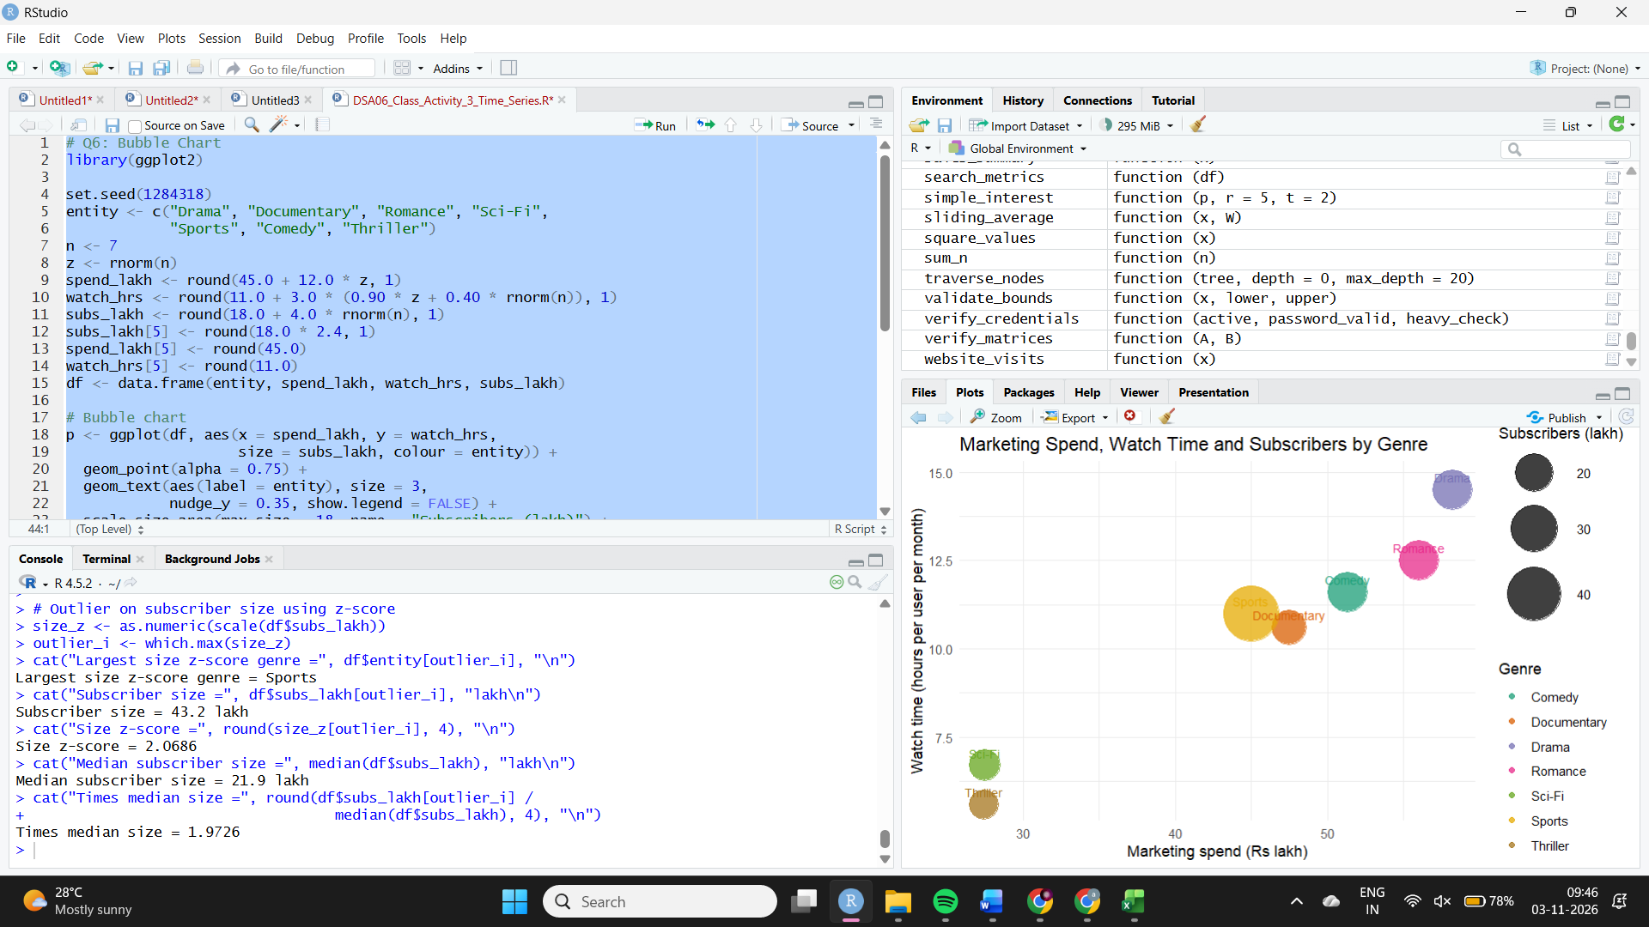

Q7 – Hexbin Plots

Aim
To visualise the relationship between loan amount and applicant income for 3,000 records, identify the busiest cell in a 10 × 10 grid, and compare hexbin and scatter plots.

R Code
# Q7: Hexbin Plot
library(ggplot2)
if (!requireNamespace("hexbin", quietly = TRUE)) {
install.packages("hexbin")
}
if (!requireNamespace("viridis", quietly = TRUE)) {
install.packages("viridis")
}
library(hexbin)
library(viridis)
set.seed(1284371)
n <- 3000
core <- runif(n) < 0.85
loan_lakh <- round(ifelse(core, rnorm(n, 38.0, 5.4),
runif(n, 11.0, 65.0)), 1)
income_k <- round(ifelse(core,
52.0 - 0.73 * (loan_lakh - 38.0) / 5.4 +
sqrt(1 - 0.54) * 7.2 * rnorm(n),
runif(n, 16.0, 88.0)), 1)
df <- data.frame(loan_lakh, income_k)
# Hexbin plot
p1 <- ggplot(df, aes(x = loan_lakh, y = income_k)) +
geom_hex(bins = 25) +
scale_fill_viridis_c(name = "Count") +
labs(title = "Hexbin Plot: Loan Amount vs Applicant Income",
x = "Loan amount (Rs lakh)",
y = "Applicant income (Rs thousand per month)") +
theme_minimal()
print(p1)
# Plain scatterplot
p2 <- ggplot(df, aes(x = loan_lakh, y = income_k)) +
geom_point(alpha = 0.35, colour = "#0072B2", size = 1) +
labs(title = "Scatterplot: Loan Amount vs Applicant Income",
x = "Loan amount (Rs lakh)",
y = "Applicant income (Rs thousand per month)") +
theme_minimal()
print(p2)
# 10 x 10 grid and busiest cell
x_cut <- cut(df$loan_lakh, breaks = 10, include.lowest = TRUE)
y_cut <- cut(df$income_k, breaks = 10, include.lowest = TRUE)
grid_counts <- table(x_cut, y_cut)
print(grid_counts)
busy_index <- which(grid_counts == max(grid_counts), arr.ind = TRUE)[1, ]
cat("Busiest loan range =", rownames(grid_counts)[busy_index[1]], "\n")
cat("Busiest income range =", colnames(grid_counts)[busy_index[2]], "\n")
busy_count <- grid_counts[busy_index[1], busy_index[2]]
cat("Busiest cell count =", as.integer(busy_count), "\n")
cat("Share of all points =", round(100 * as.numeric(busy_count) / n, 4), "%\n")
# Number of distinct x-y pairs
cat("Distinct (loan, income) pairs =", nrow(unique(df)), "\n")

Output


